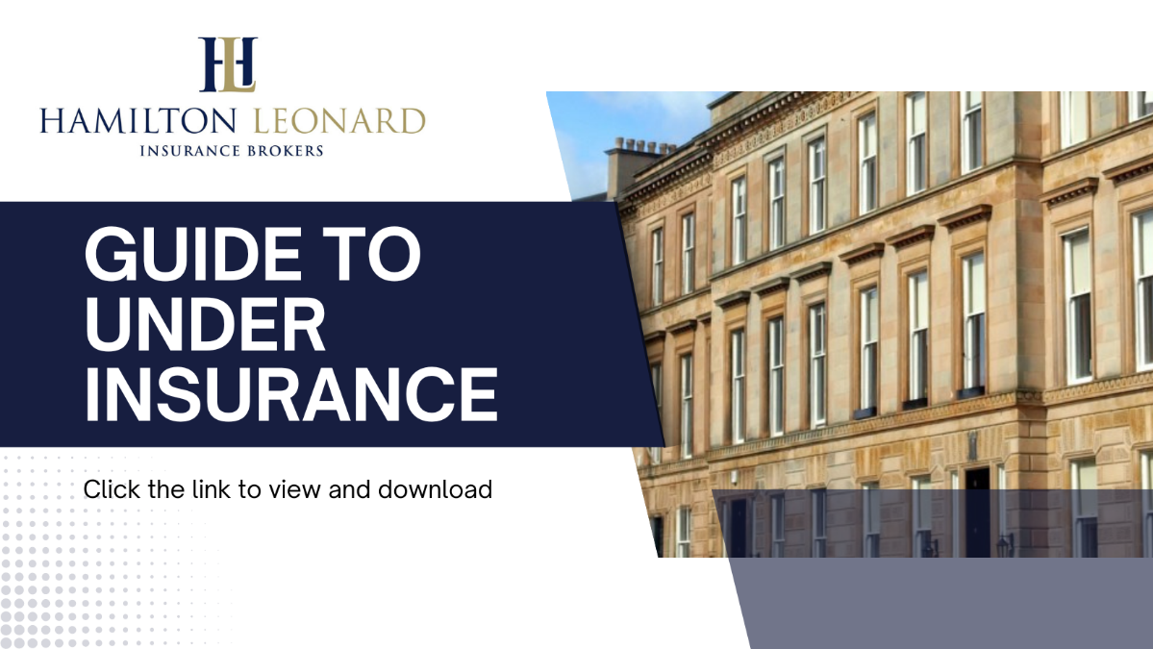
Many homeowners may not realise the effect underinsurance can have emotionally and financially, especially if the property is complex to repair or listed.
Now, more than ever with the continual increase in costs for labour, materials and replacement items extra care should be taken in ensuring an adequate Sum Insured for Buildings and Contents.
Impact of underinsurance
Underinsurance occurs when the figure calculated by your insurer to cover the damage is more than your building sum insured (which should represent the full rebuild cost of your property and not its market value) and generally comes to light in the event of a claim.
Every policyholder has to declare an accurate sum insured amount. If reasonable care is not taken this may be deemed as a deliberate, reckless or careless misrepresentation. If this is the case, your insurer may cancel your policy and refuse all claims.
If you have insured your property and then have a claim, a loss adjuster is normally appointed, who will visit the property and survey it. The loss adjuster will then calculate a rebuild cost. At that point, it is confirmed whether the property is underinsured – and if it is, the final settlement figure will be affected.
For example, if you have insured your building for £200,000 and you have a claim, the loss adjuster would review your building sums insured at the point of claim. If the loss adjuster advises your buildings should have been insured for £500,000, the difference in premiums would be calculated based on the different building sum insured. The percentage difference between the two premiums (£200,000 and £500,000) is calculated (47%). Your insurers would therefore pay 47% of the figure you originally insured your property for, meaning you would only receive a pay out of £94,000 (47% of £200,000).
Please note this can equally apply to a claim for say storm damage to a roof whereby you would only receive a percentage of the repair costs in the event of underinsurance.

Understanding sums insured

The sums insured is the amount you would receive from your insurer if you lost all of your buildings and contents.
This figure represents the total limit and will include:
- Cost of outbuildings
- Boundary structure
- Labour costs
- Architects’ fees
- Scaffolding fees
- Debris removal
- VAT

It’s important to remember even though your building sums insured may seem like a lot of money, the value represents more than just your house and everything in it.
To calculate your sums insured, this is broken down into buildings and contents;
Buildings
When considering the building sum insured, it’s important to remember the cost of rebuilding is not the same as its current market value.
If you’re in any doubt as to the accuracy of your building sum insured then we recommend you review this.
To ensure you are accurately calculating your sums insured, we recommend that you seek a formal rebuild valuation from a professional source such as the Royal Institution of Chartered Surveyors (RICS)
It is important to note most valuations will not include VAT, so you should discuss this with your surveyor as it will need to be included in the building sum insured.
Contents
It is easy to underestimate the total value of your home’s contents.

Do not forget to include items such as:
- Outbuilding contents e.g. sports or garden equipment, machinery, tools
- Carpets, curtains and linens
- Wall fixtures
- Items stored in your loft or attic

Completing a room check may seem like a daunting or time-consuming task but is worthwhile to help ensure you’re adequately covered in the event of a claim.
You will also need to make sure you do not underestimate any high value single items like an engagement ring or large screen TV.
Most Contents policies will have a maximum limit that any individual item can be worth before you need to specify it on the policy. This is often set at £1,500 but can be lower or higher dependant on the Insurer.
If your valuable is worth more than the single item limit, it will not be fully covered if you don’t declare it separately. If you have inherited or been gifted an item, it could be underinsured if its value increases over time.
If you are in any doubt over the adequacy of your Sums Insured for Buildings, Contents or Personal Possessions away from the home please let us know immediately so we can discuss your requirements in further detail.

